“Have You Seen That Tea and Consent Video?”
Posted on December 3, 2015 by bishtraining
You might have either seen the tea and consent video, or read the original blog (which I much prefer). They are increasingly being used as a teaching tool, which I don’t think is a great idea. So I thought I’d share my thoughts about what the analogy needs to be a more useful resource and why I think there are better analogies. You might also want to check out my new Consent Teaching Pack, for other unique activities for people to learn how to do consent.

Tyranny of Tea – societal pressure
The tea video goes straight into the interaction about whether someone wants tea or not. However it would be really useful to first of all point out the tyranny of tea and how it seems to be so essential to our very existence. We all receive messages (particularly in the UK and Ireland) about the importance of tea: ‘we’re a nation of tea drinkers’, ‘let’s sort the problem out over a cup of tea’, the national institution of afternoon tea. Even one of the UK national sports has a break specifically to drink the stuff.
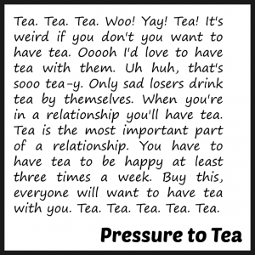
This also plays out with the people around us which: ‘the kettle’s on’, ‘there’s tea in the pot’, ‘we’re all having tea’, ‘I’m having a brew do you want one’, ‘go on have a cup of tea’. It’s presented as such a benevolent, harmless and normal thing that we can feel very abnormal for not wanting tea – or any hot caffeinated drinks at all – which puts us under a lot of pressure to get used to drinking it (even if we really don’t like it).
Same with sex right? Sex is seen as such a benevolent, healthy and normal activity that everyone is expected to do it. To not want sex at all: because someone isn’t interested, or wants sex in a committed relationship, is practicing celibacy, or is asexual is seen as so unusual that people receive tremendous stigma about it.

Tea is for everyone – sex isn’t
However although pretty much everyone is expected to drink tea, and receives status if they do so, it’s not the same for sex. Only some people are seen as being able to have sex (e.g. not disabled and over 16 but under 50) and some people get status for doing it and some stigma. When we factor in all of our different identities (e.g. genders, sexual identities, age, race, class, disability, HIV status, etc) we might find that sometimes we are given more or less status or stigma around our sexuality depending on our oppressions and privileges.
Often this is played out between what men are taught about sex (e.g. lad points, real man, stud, men love sex all the time) and what women are taught (e.g. slut, slag, sket, women are not meant to like it). But think about all the other messages that people hear from different groups and add them all together if this applies. These powerful messages come from everywhere and are played back to us from an early age until now, sometimes consciously and directly but often not. They are very difficult to escape or deal with or process and they can have a huge affect on our sexual decision making and our sense of agency.
If we factor in another person (or people) here then we can see that we may often have more or less power in a sexual encounter – we need to be able to have a sense of this with the people around us, in all encounters, not just sexual. However because of the seeming convergence of sex and relationships (the idea that we ‘must’ have sex if we are in a relationship and that the only time sex is allowed is when we are in a relationship) this also means that there is often a difference in power in relationships too. I’ll reflect on this a bit later on.

What counts as tea – normative scripts
If I ask for ‘a cup of tea’ in the UK I know what I’m going to get: English/Irish breakfast blend with some milk. There’s a very strong script of what counts as tea – anything else is a bit exotic, or specialist, or frankly sometimes just not tea. Maybe you might get asked how strong you like tea (how much milk you want), or how many sugars, but that’s it.
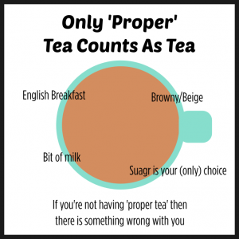
Same with sex right? A huge part of consent is recognising that the choices we make are massively restricted by the messages about what it is that we are allowed to do. Sex is penis in vagina sex: anything else is seen as exotic, specialist or frankly just not sex. This kind of sex is the only game in town and we’re under a lot of pressure to do it even if we don’t want to. And of course if we don’t have the bodies that can do penis in vagina sex then we are excluded altogether.

Not saying no – power in relationships
Like many people I often imagine Nigella Lawson asking if I’d like a cup of tea. I don’t think that I could do anything other than say ‘yes please, I’d love a cup of tea’ even if I didn’t actually want a cup of tea. I don’t think there’s any way I could be cool and say something like:
‘sure, what kind of tea do you have in mind’
‘how are you going to brew it’
‘are you having the same or would you like me to make you something different?’
I’d just nervously agree to the tea because I really really fancy her and just want her to like me (or for her not to dislike me).
I think if the tea arrived and I didn’t like how she brewed it (e.g. she used a tea bag and even put the milk in before taking the tea bag out) I think I would drink the tea anyway. I think I would even pretend it was a really great cup of tea even if I thought it was terrible. I’d probably make sure to drink all of it even if it was a giant seemingly endless mug of tea. I wouldn’t want her to think that I didn’t enjoy it and I’d also feel guilty about not drinking a cup of tea that someone had offered me and spent some time preparing even though I didn’t want it in the first place.
In the tea video there’s nothing about the power of societal and cultural scripts and messages about what counts as tea, but there’s also nothing about the power in interpersonal relationships. Interactions about whether people have sex or not often involve higher stakes than negotiations about a cup of tea and often the stakes can be higher for one person than it is for another.
In my example about me and Nigella, to her offering a cup of tea might be a kind but mundane gesture, to me it would mean something entirely different as it might mean acceptance or interest from a famous person I fancy a lot. Imagine how I would feel if Nigella asked me out on a date!
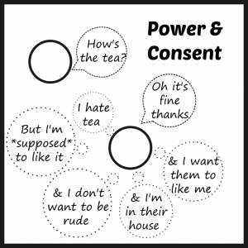
But enough about Nigella and me (*swoon*), power exists where people know each other too. For example in a long term cohabiting relationship turning down a cup of tea, or asking for a different kind of tea or different kind of drink altogether, or having a cup of tea given to you even if you didn’t ask for one is no big deal. But if we substitute tea for sex here, it can be a huge deal. Also the pressure to have sex in a ‘love’ relationship is huge and often people think that because they are in love they should have sex – whenever their partner wants. Or sometimes the word love can be used to coerce people into sex: ‘but I thought you loved me?’
We can’t step outside of the messages of culture and society but it’s also difficult to step out of the almost inevitable power differences between people and this can have a huge impact on how much agency we feel we have. We can see that this stuff is actually quite complicated. It’s also about far more than just yes or no.

Tea might be yes/no but sex isn’t
One of the biggest problems when we over simplify conversations about consent is when we boil it down to a one time yes or no negotiation. I’ve worked with and listened to many many people (thousands) about consent and sexual encounters and it’s clear to me that we need much more than a yes means yes and no means no understanding of consent. From the student who said: “so if two people have sex and neither of them says yes or no, is it consensual sex?” to the woman who when I asked whether sex was consensual or not she said “yeah I didn’t say no, so it wasn’t rape.” On the one hand of course yes means yes and no means no, and the absence of a no does not mean a yes, but we all need much more than this very simple message to understand how consent feels for us and how to practice it.
The ability to use words to get and give consent is great for people who are confident enough to say ‘would you like to have sex?’ or ‘yes I would like to have sex’. But many people just aren’t able to do that – see above about agency, power and who is allowed to have sex. Even if people were able to do this, that agreement only applies at that fixed moment in time. Tea might be a one off decision resulting in a binary result of having tea/not having tea, but sex isn’t.

Checking in and paying attention
So going back to Nigella. I’d like to think that she’s pretty cool and understands that there is a power dynamic going on and that even though I said ‘yes’ to the tea I might actually be pretending to enjoy it.
So I reckon she might pay really close attention to whether I really wanted the tea: how enthusiastic was I in my response, did I seem happy when she put the mug down, what my facial expressions are when I’m drinking it, am I making noises indicating enjoyment, how quickly I’m drinking it, how much I drank. I think she’d check in with me afterwards too. I’d like to think that at any point if I seemed unhappy she’d offer to make me another drink, or very gently give me permission to leave it, or not make a big thing about not taking it with me when we move into another room.
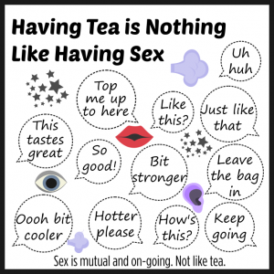
Maybe you could try this the next time you have a cup of tea with someone?
Sexual consent isn’t a one time yes, no negotiation. It’s a constant series of decisions, negotiations and communications. If someone has clearly and verbally agreed to sex, or whether they are following a script for sex (e.g. kissing, ‘foreplay’, penis in vagina), it’s important to keep paying attention to them and to check in if we’re not sure that they are enjoying it, or at least not not enjoying it. This is where the tea analogy really falls down in my view.

Closes down conversation
Many people have said that it’s not a perfect analogy but at least it opens up the conversation about consent. Mmmm maybe. I think the tone of the blog and the tone of the video are kind of different. The video implies that consent is all very simple: if someone doesn’t want tea don’t give them tea, if someone is asleep they can’t consent to tea, don’t give them tea. In my view the tone of the video is there are smart people who get this and there are stupid people that don’t.
I don’t think so. I think it’s totally possible to understand this view of consent but also to act in a non-consensual way. I think it’s also good to reframe the ‘they’ to a ‘we’ because I think the video creates this idea of an ‘other’ or a ‘them and us’. We are all capable of behaving in consensual and non-consensual ways when it comes to sex, bodily contact and social situations – all of us.
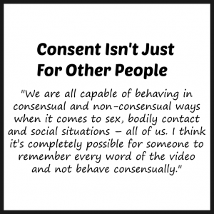
If we’re sleeping over with someone how to check if we can touch each other in the middle of the night. Knowing what to do with our hands when snogging. Not touching people on the dancefloor or at a gig without any communication that that is what they wanted. Hearing other people when they say they don’t want another drink. Respecting people when they want to stay in. Asking if holding hands or hugging is okay. Being able to ask open questions rather than closed ones. Understanding that it’s harder for some people to say what they want for dinner than others. Asking before we touch or hug people.
Why doesn’t this work as a sex education tool? It’s simplistic but it’s also just about knowledge. I think it’s completely possible for someone to remember every word of the video and not behave consensually. Good sex and relationships education is about skills (e.g. communication), values (e.g. understanding power difference) and our own feelings (e.g. what it feels like for someone to really respect what you want). The tea thing isn’t very people centred. If you’re going to run a workshop or a class about consent you need to give people an opportunity to really explore their own actions and how this feels for them. It’s maybe a useful thing to share on social media and say ‘have you seen this?’ but really, has it helped you to understand consent? Has the way you’ve though about consent changed? Have your behaviours changed at all after watching the video?
Folk are tired of just being told what to think. Good SRE is about giving people the space to think critically and a safe space to reflect on their own stuff. This is why I prefer working with an experiential learning method around consent – such as handshakes, which Meg John Barker and I have been working on. Go and check it out, it’s totally free. MJ and I have done this with therapists, teachers, youth workers, academics, young people at school and Uni and even paying members of the general public – it works really well.
If you’re working with over 14s you might want to sign up for free support, resources and lesson plans (written by me and Alice Hoyle with advice and guidance from Meg John) to deliver a unique six week SRE programme which is all about self (and power), what is expected of us, love, consent and reducing risk. Check out DO… it’s all free.
For a post about how consent might feel go here, for how to put that into practice go here,
If you’d like to book a training course with me on consent for up to 16 people go here. Or if you would like me to come and teach it in person go here.
© Justin Hancock, bishtraining.com 2015

